C:\Users\L.Fitzpatrick\AppData\Local\Microsoft\Windows\INetCache\Content.MSO\F586F9D0.tmp

Ladybirds – Jackson

Year 1 – Willow

Year 2 – Nevaeh

Year 3 – Max

Year 4 – Kai-Hei

Year 5 – Jaiha

Year 6 – Phoebe -Mai

**News…**

Unfortunately, I need to begin by sharing the sad news that Mr Massam will be leaving us at the end of this term. We are extremely sad to see him leave and he will be very much missed by staff and the children. Very excitingly, he has secured a fantastic job working with the Commonwealth Games team in Birmingham and we are very happy for him. This is such an exciting opportunity that I know he could not turn down.

Many thanks for supporting our **PTFA film night** – this was a huge success and films chosen by the children really helped start the Christmas season off. The total amount raised was £732.50! Amazing!

The PTFA school Christmas disco is next week on Wednesday 8th December. £2 per child to be paid on the door. KS1 – 4.15pm-5.15pm and KS2 – 5.30pm – 6.30pm.

Reminder that it is **parent consultation meetings** on the afternoon and evening of the 14th December. We still have a couple of parents who have not made appointments. These can be either face to face (if after 3.30pm) or over the telephone. If you want to meet your child’s teacher face to face, please message them on DoJo. Masks will need to be worn for face to face meetings. If you need any help making your appointment on MYCAS, please contact the school office.

The **Christmas season is now upon us** – this is very exciting. As Mrs Jones said earlier in the week, we plan to go ahead with all our planned activities as we have already put many safety precautions in place. These will be subject to last minute cancellations if restrictions change nationally or local/school cases increase. I am very disappointed to be missing all the festive celebrations and performances, as I know they will be fabulous.

Children can wear their **Christmas jumpers** when it is their Christmas craft day, on the 15th for Christmas lunch and on the last day on term (17th).

Please see DoJo, our school website and the list on the next page of this newsletter for all school dates.

Our **books Christmas wish list on Amazon**  is going so well – we have had many wonderful books gifted already and Miss Noakes has presented these in a lovely Christmas gift bag to the classes. Inside each book is a label saying thank you to the pupil who gifted this to our school. Thank you so much for your generosity. 🙏🏻📚 There is still an opportunity to gift the school a book.

There will be **no clubs** after school in the **last week of term** except for the Mark Albrighton football on Monday.

**Birthday celebrations!**

Kitty

Molly H

Dylan

Ava

**This week’s MacGregor Mile Winners are**

**Year 4**

**Running 45 miles**



👫 Every week, there will be a battle in each class. Boys VS. Girls. 👫

Good luck! 🤞🏼

**This week’s most valuable players:**

**Year 2: Liliana & Noah🥇**

**Year 3:Toby & Gracie🥇**

**Year 4: Kai-Hei & Kitty🥇**

**Year 5: Alexia & Jude 🥇**

**Year 6: Harvey & Szeki 🥇**



**Leaderboard this week:**

Year 3

Year 5

Year 4

Year 2

Year 6

Year 1

**Top Spellers:**

**🥇 -Sarah T – Y3**

**🥈 – Leart G – Y3**

**🥉 – Freddie B – Y4**

**Congratulations to all badge winners this week**

**Bronze badge** – Ayla

**Silver badges** – Isabella {Yr2} Amelia and Seb {Yr4} Jahia, Tayla and Jude {Yr5}

**Gold Badges** – Charlie, Elijah, Lily, Evie, Molly, Lewis, Euan, Ivy, Liliana, Darcy, Isabelle, Keanan, Maggie and Sophie Alisha, Isla, Kai, Kitty and Tamzin {Yr4} Millie, Alex and Megan {Yr5}



**Leaderboard this week:**

Year 2

Year 6

Year 5

Year 3

Year 4

Year 1

**Top Mathstronauts:**

**🥇 - Liliana – Y2**

**🥈 – Andrei O – Y6**

**🥉 – Nevaeh – Y2**



Please click on this link to find out events taking place at St Georges Church on Bamford Street. Rev Gary Simmons and St. George’s have close links with our school and we are very lucky that they visit school regularly to talk to the children. Gary will be delivering assembly next Monday – we are very happy to welcome him back into school.

<https://stgeorges-glascote.org.uk/events/>

**School events**

Reminder that our school website has all events taking place in school. [www.williammacgregor.staffs.sch.uk](http://www.williammacgregor.staffs.sch.uk)

**December**

7th Yr6 Christmas Craft 9-10.15am

Yr5 Christmas Craft 10.45-12

8th PTFA School discos

9th Yr1 and Yr2 nativity at St.Editha’s church. 6pm

10th Ladybirds nativity at Elim Church 9am

10th Yr3 Christmas Craft 9-10.15am

Yr4 Christmas Craft 10.45-12

13th Yr2 Christmas Craft 9-10.15am

14th Yr1 Christmas Craft 9-10.15am

LB Christmas Craft 10.45-12

14th Parent consultation meetings 1.30pm-6.30pm

15th Christmas lunch & Christmas jumper day

17th End of autumn 2 & Christmas Jumper day

**January**

4th staff training day

5th start of spring 1

**Financial Support for Residents and Families Facing Financial Hardship**

Staffordshire County Council are offering financial support to vulnerable individuals and families who are struggling with money this winter by awarding eVouchers for:

* **Food and essential supplies**  
  eVouchers will be sent by email or text and can be redeemed at Aldi, ASDA, Morrisons, Sainsbury’s, Tesco, Waitrose or Marks & Spencer’s.
* **Gas and Electric home heating costs (up to £350 per household).**  
  As well as free emergency heating appliances. The eVouchers will be provided by pre-paid meter credit or paid directly to energy providers.

**These offers are limited and will be allocated on a first come first serve basis.**

If you are in need of support, please apply at [www.staffordshire.gov.uk/wintersupport](http://www.staffordshire.gov.uk/wintersupport)

Please note: Applicants **must complete BOTH application forms** if they want to receive support for both food and essential supplies **and** home heating funding.

If residents need help completing the application forms, they can contact Staffordshire County Council’s Customer Service Team on 0300 111 8000.

**Fundraising – School lottery fortnightly update**

Congratulations to Mrs Hadley who won £12.60 last week.

We have raised £ 1621.20 so far.

We have a new area we are fund raising for now and this is the area to the side of the trim trail. We would like to put artificial grass here and develop a calm area where the children can relax.

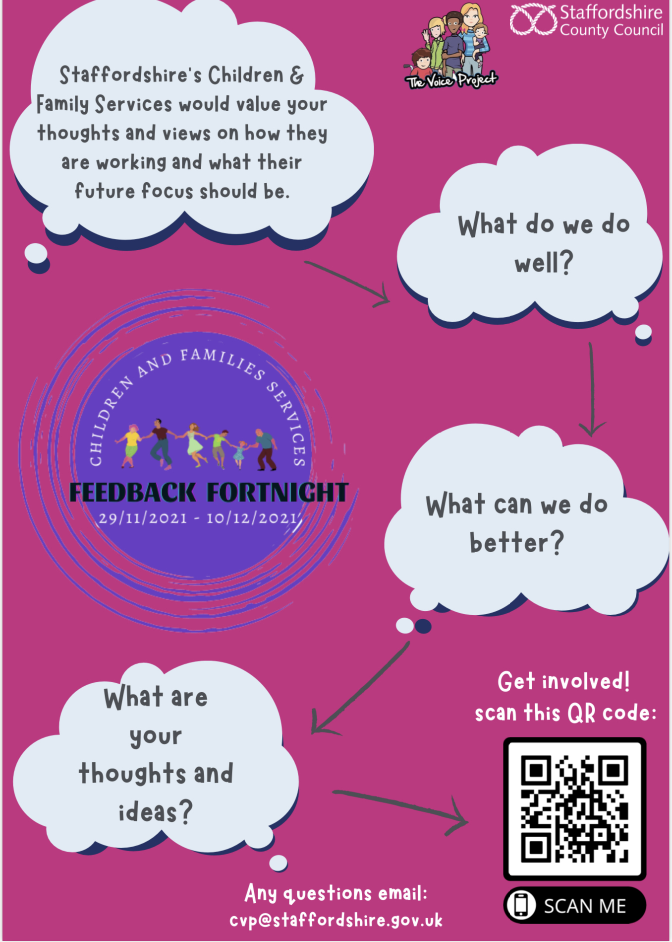

**Next week’s assembly topic. Please use this information to discuss this as a family at home. I am sure it will bring about great discussions!**

