News…
This week we have had two headteachers from ATLP come and join us for a morning. The purpose of their visit was to work closely with us and explore our strengths and areas for development in the teaching of reading and phonics. This is a key area for us and forms part of our school improvement plan for this year. We want to ensure that our teaching in these areas is outstanding and the quality of the provision the children are receiving is ensuring they make the best possible progress. Our teachers and support staff received some great feedback and we are so pleased with the outcome. We have a few areas of development to work together on and we will be looking at this more closely on our staff training day next Friday. I am always so pleased with the staff and am very proud of them. Both head teachers said how fabulous our children are – they really are!
INSET DAY – School is closed on Friday 22nd October for a staff training day meaning school will close on Thursday 21st October for half term. We will be back in school on Monday 1st November.
Attendance in school at the moment is a concern. Current Government guidance asks that children with any symptoms of covid need to remain at home and gain a PCR test. If a child has been in close contact with somebody with covid, they should also get a PCR test, however they can come in to school in this instance whilst they await their test result. Please can I ask that if children are not displaying covid symptoms and can be in school that they are. Attendance is compulsory and children need to be accessing daily learning. Appointments should not be taken in the school day and holidays/leave of absence will not be authorised unless there are exceptional circumstances.
A very big thank you for all your harvest donations – we have been overwhelmed with the amount we have received. We will take these up to our local food bank next week.
Ladybirds – Gabriel
Year 1 – Isabelle
Year 2 – Toby
Year 3 – Brody
Year 4 – Alfie D
Year 5 – Alexia
Year 6 – Georgie-Lea

Congratulations to all bronze badge winners this week.
Bronze
Y1 – Evelyn-Rose, Millie, Emelia P, Willow, Lottie, Dixie, Pearl, Layla, Martynas, Emelia G, Bella, Joshua, Jaxon, Zachary, Lilly-May and Archie
Y3 – Livy, Ella R, George, James and Ella Ro
Y4 Alfie A
Y5 – Terlea, Ronnie and Chase
Y6 – Louie and Ellie-May
Silver – Martynas and Katherine
Last week’s MacGregor Mile Winners were Year 3
Having run 58 miles!

Birthday celebrations!

Corey
Pearl
James B

Every week, there will be a battle in each class. Boys VS. Girls.
Good luck!

This week’s most valuable players:
Year 2: Nevaeh & Euan
Year 3: Finn & Sarah
Year 4: Kai-Hei & Victoria
Year 5: Alexia & Alex
Year 6: Harvey & Szeki

Leaderboard this week:
Year 5
Year 4
Year 3
Year 2
Year 6
Year 1
Top Spellers:
- Alexia F – Y5
– Aida O – Y5
– Brody H – Y3

Leaderboard this week:
Year 2
Year 6
Year 5
Year 4
Year 3
Year 1
Top Mathstronauts:
- Emi – Y2
– Andrei O – Y6
– Charlotte H – Y4

School events
Reminder that our school website has all events taking place in school. www.williammacgregor.staffs.sch.uk

October
21st end of autumn 1
22nd staff training day
25th-29th half term week
November
1st start of autumn 2
29th Staff training day
December
9th Yr1 and Yr2 nativity at St.Editha’s church. 6pm
10th Ladybirds nativity at Elim Church 9am
13th Christmas craft morning 8.45-10.15am (one parent/relative per child)
14th Parent consultation meetings 2-7pm
15th Christmas lunch
17th Whole school carol service at St.Editha’s 2pm
End of autumn 2
January
4th staff training day
5th start of spring 1
Fundraising – School lottery fortnightly update
Congratulations to Miss D Lane who won £12.90 last week.
We have raised £ 1498.80 so far.
We have a new area we are fund raising for now and this is the area to the side of the trim trail. We would like to put artificial grass here and develop a calm area where the children can relax.

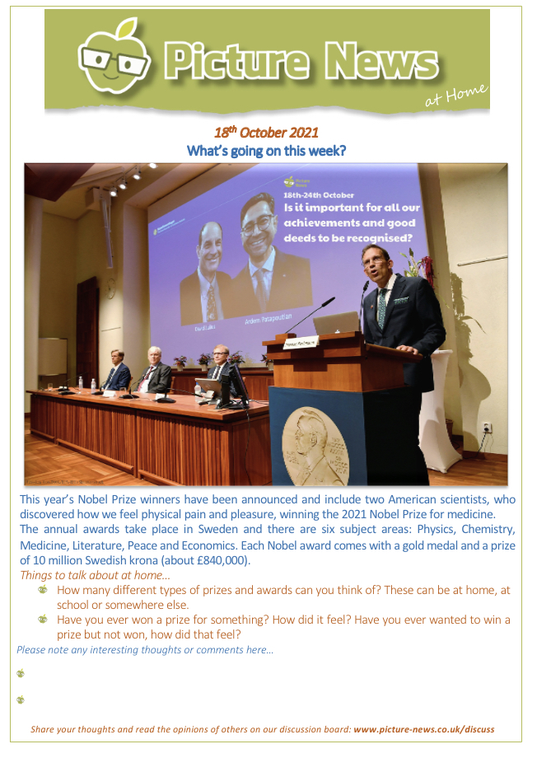
Assembly Topic next week

School Admissions and Transport Service
2 Staffordshire Place, Tipping Street
Stafford
ST16 2DH
Telephone: 0300 111 8007
E-mail: admissions@staffordshire.gov.uk

01 November 2021

Dear Parent/Carer

IMPORTANT INFORMATION - ADMISSION INTO RECEPTION CLASS SEPTEMBER 2022

To be sure of receiving an offer on national offer day please apply online through our website www.staffordshire.gov.uk/admissions.

The online system will ask for a UID number – please click ‘No UID’, this will allow you to continue with your application.
You will need to make your application by 15 January 2022 and your child will receive an offer of a reception place on national offer day 18 April 2022.

All the information you need about the admissions process within Staffordshire is available on our web pages.

Please be sure to read the reverse of this letter and use our "school search and compare" facility on the Staffordshire website. You can also check if your child will be eligible for free home to school transport by visiting www.staffordshire.gov.uk/schooltransport.

You must apply for all schools that you would prefer your child to attend including schools outside of Staffordshire or grammar schools. You will need to check the admissions arrangements for each school you are interested in to see what priority will be given to your application and whether you should provide additional information or a supplementary form with your online application.

If you do not make an application your child will be disadvantaged as children whose parents/carers have applied will be given priority for popular schools.

You must apply even if you have an elder child already attending the school (or affiliated Junior). No priority is given in the admission process because your child is currently in a nursery class and there is no guarantee that they will be allocated a place at the school at which they currently go to nursery.

If there are other persons with parental responsibility for your child, who are not living at your home address, it is expected that you will jointly agree on school places before an application is made. The local authority is not able to intervene in disputes between parents over school applications and will request that these are resolved privately.

If you require any assistance or further information, please call us on the telephone number above.

Yours faithfully

School Admissions and Transport Service

Important points to remember

- You must apply by 15 January 2022. Last year there were nearly 700 late applications which may have affected the outcome of these applications.

- You must make an application, even if you have an elder child attending your preferred school.

- You are strongly advised to make more than one preference. Failure to do so could have repercussions in terms of the distance your child is required to travel to school.

- You will not gain an advantage by only listing one preference and this could affect your chances of being allocated a place at a local school within a reasonable distance from your home address. Do not list the same school three times.

- All applications are considered at the same time. Priority is not given to those who put the school as a first preference, or on a ‘first come first served’ basis.

- List the schools in the order that you would most prefer them and not the order you think you might get them.

- The order in which you list the schools is only used if you can be offered more than one school. In this case, you will be offered whichever of those schools is ranked highest in your application.

- Be realistic about the schools you apply for. It is recommended that you include your catchment school as one of your preferences, as otherwise your child may not be considered for a place.

- ` Understand the admission arrangements for each of your preferences. This will enable you to assess what order of priority will be given for each school.

- Check the admission arrangements for your preferred schools as you may be required to provide additional information or submit a supplementary form. It is your responsibility to provide any supportive information e.g. baptismal certificate. The Local Authority will not seek to obtain this information on your behalf.

- Consider how your child will get to school. Very few children are entitled to free or discounted home to school travel assistance. You can check if your child is entitled by visiting www.staffordshire.gov.uk/schooltransport.

- You will be notified of your child's offer on 18 April 2022 and not before.

