

Welcome back to the summer term! We are so excited to embrace the new term and all the exciting things that come with school life in summer. The weather has not been playing ball much this week though and we started our week with many wet play times but I am so hopeful of the children playing on the field as soon as possible; they are already asking!

I wanted to start the summer term with some staffing news. I want to extend a big congratulations to Mrs Simpson and her family as she is having a second baby. Mrs Simpson will be with us in school until September before she begins her maternity leave.

The children had a very fun filled morning on Wednesday as the fire and rescue service joined us in school. The whole school had the opportunity to explore the engine and have a go at pretending to put out fires. I was not in school and missed it but the staff and children were full of enthusiasm when I retuned after lunch. It was lovely so see and hear the children so excited as they were leaving school on Wednesday telling their adult.

Year 2 also had lots of fun at Tamworth Castle on Tuesday on their trip. The children explored the castle and took part in some workshops which supported their in class learning on castles. The lady who led the workshops and tour commented that the class were the best they had had all year which made Miss Crowther and I very proud. Well done year 2! Thank you too to our volunteers who went along to support the children. Next week year 5 embark on their overnight trip to London. I will share their exciting activities next week.

Unfortunately this week I have had a complaint from one of our neighbours about some very inconsiderate parking that occurred. Please when dropping and collecting children from school be considerate that we are in a residential area and please do not park across driveways blocking others in. Another reminder also that children ARE NOT to be dropped off on the yellow lines outside of school. This is dangerous for all of our children.

Can I also remind you that earrings can be worn in school but only small, plain, stud earrings are permitted. I am seeing an increasing number of children with inappropriate earrings in for school that are far too big and colourful. These are not part of school uniform and are unsafe whist children are playing outside. Earrings are not to be worn on PE days at all.

Have a lovely weekend! Mrs Jones x

**Ladybirds -** Evie

**Year 1** – Logan

**Year 2** – Mason

**Year 3** - Dylan

**Year 4** – Lewis

**Year 5** – Chace

**Year 6 -** Ted and Beau





**Leaderboard:**

Year 6

Year 2

Year 4

Year 3

Year 5

Year 1

**Top Mathstronauts:**

🥇 - Tamzin H - Y6

🥈- Liliana D - Y4

🥉 - Charlotte H - Y6







**Leaderboard:**

Year 3

Year 2

Year 4

Year 6

Year 5

Year 1

**Top Spellers:**

🥇 - Kyren S - Y3

🥈- Lucas H - Y3

🥉 - Archie A - Y2



**Congratulations to all of the children who have improved their rock speed this week!**

**Rock Hero (under 1 sec) -**

Olivia L

**Rock Legend (under 2 secs)-**

**Rock Star (under 3 secs)-**

**Headliner (under 4 secs) -**

**Support Act (under 5 secs)-**

**Breakthrough Artist (under 6 secs)-**

**Key Dates**

**April:**

**16th - 17th:** Y5 to London

**19th:** LB on trip to Twycross

**May:**

**1st:** Y1 trip to Sudbury Hall

**1st:** PTA school disco

**2nd:** School closed for polling day (Y6 in school)

**3rd:** Inset day, school closed

**6th:** Bank holiday, school closed

**13th - 17th:** Y6 SATs week

**20th-24th:** Health week

**23rd:** Sports day

**24th:** Last day of half term

**June:**

**3rd:** First day of Summer term

**5th:** Reception 2024 new intake meeting 6pm

**10th - 13th:** Book Fair in school

**19th:** PTA school disco

**26th:** ATLP student awards

**July:**

**5th:** INSET day, school closed

**6th:** Summer Fair (12-3pm)

**W/b 8th:** Reports out

**10th - 12th:** Y6 secondary transition days

**19th:** Last day of term

**September:**

**2nd:** INSET day, school closed

**3rd:** INSET day, school closed

**4th:** First day of the autumn term for all children 20224





**Congratulations to all of our badge winners this week! 🤩**

**Silver – Mason (Yr2) Pearl (Yr3) Alfie D (Yr6)**

**Gold – Gracie, Isabel (Yr5) Jenson, Mason (Yr6)**

**Emerald – Toby (Yr5)**



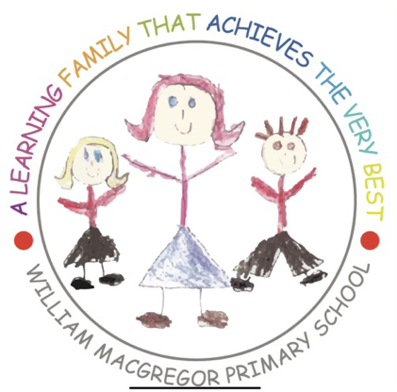******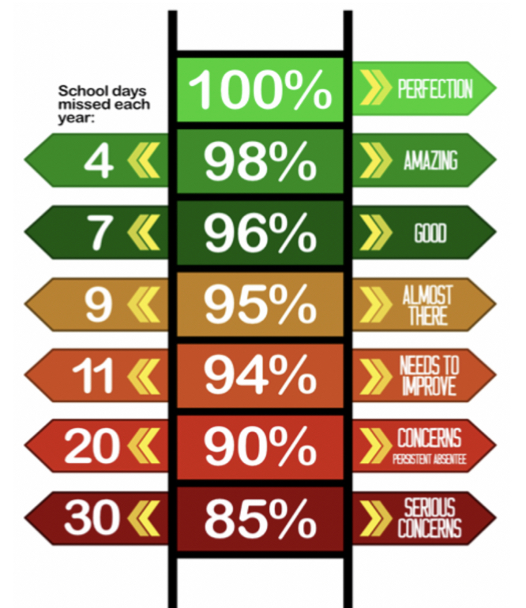**

**Year 6 have the best attendance this week!**

Congratulations to Miss R Pritchard who won £4.80 last week.

**We have raised £2890.80 so far.**

We have a new area we are fundraising for now and this is the area to the side of the trim trail. This will be an area dedicated to reflection, one that reaches our senses and provides an area of calmness and sanctuary.

**Happy birthday to all children celebrating their birthday this week! 🥳**

Louis

Chloe

**Whole School:** 96.5%

**Ladybirds:** 94.1%

**Year 1:** 97%

**Year 2:** 94.4%

**Year 3:** 98.4%

**Year 4:** 97.4%

**Year 5:** 94.8%

**Year 6:** 99.6%

**IT IS GOOD TO BE GREEN!**

COME ON WMG, WE NEED TO IMPROVE ATTENDANCE!

**WE ARE AIMING FOR 97%**

THE CLASS NEXT WEEK WITH THE BEXT ATTENDANCE GETS AN EXTRA PLAYTIME

**Why is high attendance important for your child’s education?**

**As a parent/carer you want the best life chances for your child/children. Being in school every day gives them the very best chance of achieving this. GCSE’S may seem a long way off for your child but 90% of children with average attendance at primary school and into secondary school of around 85% fail to achieve 5 or more GCSEs and one third of children fail to gain any.**

**Poor attendance in school will limit children’s ability to achieve their full potential and this will impact opportunities in life.**