

I am starting his week with some sad staffing news. As you may know ATLP are opening a brand new school over on the new Ventura estate. This school will open with a nursery and reception class and just before Easter Mrs McNerlin was successful in securing the role of reception teacher. We are so pleased for Mrs McNerlin and that she will be staying in the ATLP central hub family but she has been a huge part of our journey at WMG so we are very sad to say goodbye. Mrs McNerlin will leave us in July; I know you will wish her lots of luck in her new role at Dunstall Primary.

Miss Tipton and Miss Wadsworth will join us as new teachers in September.

As we continue to grow our team, we also have a vacancy currently for a lunchtime supervisor. Please follow the link attached if you would like more details. This vacancy is to start asap.

This week, year 5 have had the most incredible experience on their residential to London and what a few days they had. On Tuesday morning, year 5 and four staff joined Curdworth Primary and staff and embarked on an early train to our capital city. Day one included a London Eye trip, a visit to Shrek Adventure and a river boat cruise down the Thames. We also squeezed in a walk past Downing Street and lunch in St. James Park. The incredible day was finished by the children staying aboard the HMS Belfast for the night and taking part in some evening activities. On day two, children had a tour of the Houses of Parliament and went to watch the WestEnd show: Wicked! It was such a great two days and the chidlren made so many memories. I am so glad that we are able to provide these experiences for the children. A big thank you to the staff Mr Neiland, Miss Archer and Mrs McNerlin in accompanying the children.

If you have a child starting school in September, you will have this week received their offer of a school place. Again we remain a school of choice for our local community and I am pleased that we have a full class starting with us for another year. Letters and induction packs will be on their way out to you in the next few weeks with lots of key dates and information in so pease look out for this.

Ladybirds have also been on their own adventure today and have had a great day out at Twycross Zoo. The children have seen lots of animals and explored their characteristics and features. The children had a great day and were very excited on their return to tell everybody what they had seen.

For parents of children in years 3-6, please ensure if you are ordering a school lunch that the payment is also made at the same time to ensure that you do not get behind on these payments and get into any difficulty paying. If you think you may be entitled to free school meals, please call in at the office and the office staff will show you how to apply.

Please note on the calendar that the summer fair has moved date from the 6th July now to the **13th July.** This is always a great community event that raises money for our children. Pop it on your calendar!

Thank you for your generosity for the Easter raffle – we raised £245. This money will be given to Tamworth Foodbank.

Have a lovely weekend! Mrs Jones x

**Year 1** – Carter M

**Year 2** – Mia

**Year 3** - Brooke

**Year 4** – Emi

**Year 5** – Noah

**Year 6 -** Kai-Hei





**Leaderboard:**

Year 6

Year 3

Year 2

Year 4

Year 5

Year 1

**Top Mathstronauts:**

🥇 - Orson W - Y6

🥈- Alexander L - Y3

🥉 - Kitty F - Y6







**Leaderboard:**

Year 4

Year 2

Year 3

Year 5

Year 6

Year 1

**Top Spellers:**

🥇 - Noah M - Y4

🥈- Lucas H - Y3

🥉 - Archie A - Y2



**Congratulations to all of the children who have improved their rock speed this week!**

**Rock Hero (under 1 sec) -**

**Rock Legend (under 2 secs)-**

**Rock Star (under 3 secs)-**

**Headliner (under 4 secs) -**

**Support Act (under 5 secs)-**

**Breakthrough Artist (under 6 secs)-**

**Key Dates**

**May:**

**1st:** Y1 trip to Sudbury Hall

**1st:** PTA school disco

**2nd:** School closed for polling day (Y6 in school)

**3rd:** Inset day, school closed

**6th:** Bank holiday, school closed

**13th - 17th:** Y6 SATs week

**20th-24th:** Health week

**23rd:** Sports day

**24th:** Last day of half term

**June:**

**3rd:** First day of Summer term

**5th:** Reception 2024 new intake meeting 6pm

**10th - 13th:** Book Fair in school

**19th:** PTA school disco

**26th:** ATLP student awards

**July:**

**5th:** INSET day, school closed

**W/b 8th:** Reports out

**10th - 12th:** Y6 secondary transition days

**13th:** Summer Fair (12-3pm)

**19th:** Last day of term

**September:**

**2nd:** INSET day, school closed

**3rd:** INSET day, school closed

**4th:** First day of the autumn term for all children 20224





**Congratulations to all of our badge winners this week! 🤩**

**Silver – Charlie (Yr1) Jackson (Yr2) Summer-Mai (Yr3)**

**Ted, Lexi (Yr6)**

**Gold – Carter H, Jacob (Yr1) Gabriel, Elsie, Daisy, Leon**

**(Yr2) Isabelle, Hugo, Lily (Yr3) Keanan (Yr4)**

**Emerald – Evie, Isabella, Logan, Olly, Lili (Yr1)**

**Katherine (Yr3) Isabelle, Lily, Luna, Evie,**

**Liliana (Yr4)**



******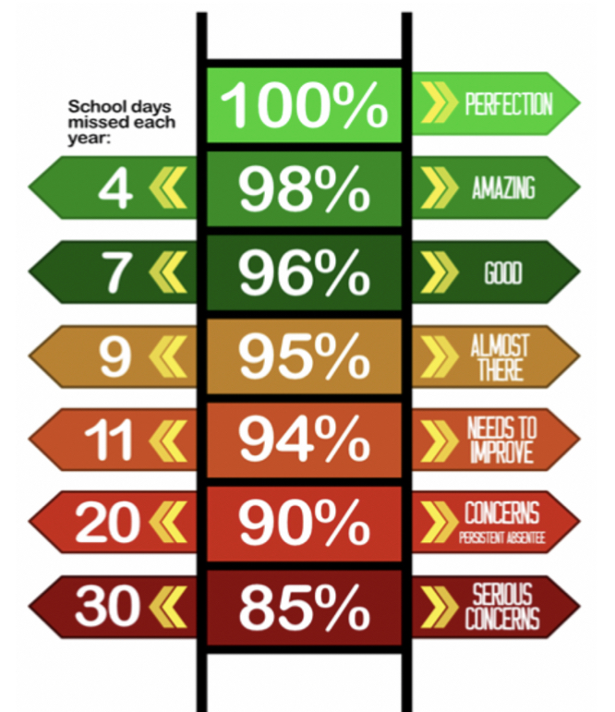**

**LB have the best attendance this week!**

Congratulations to Mrs C Fairfax-Haycox who won £5.10 last week.

**We have raised £2923.20 so far.**

We have a new area we are fundraising for now and this is the area to the side of the trim trail. This will be an area dedicated to reflection, one that reaches our senses and provides an area of calmness and sanctuary.

**Happy birthday to all children celebrating their birthday this week! 🥳**

Skylar Iacob

Akshian Joshua H

Nevaeh Charlie FH

Livy Ella Ro

Toby S

**Whole School:** 95.6%

**Ladybirds:** 98.6%

**Year 1:** 96.6%

**Year 2:** 91.7%

**Year 3:** 92.9%

**Year 4:** 96.9%

**Year 5:** 98.3%

**Year 6:** 93.9%

**IT IS GOOD TO BE GREEN!**

COME ON WMG, WE NEED TO IMPROVE ATTENDANCE!

**WE ARE AIMING FOR 97%**

THE CLASS NEXT WEEK WITH THE BEXT ATTENDANCE GETS AN EXTRA PLAYTIME

**Why is high attendance important for your child’s education?**

**As a parent/carer you want the best life chances for your child/children. Being in school every day gives them the very best chance of achieving this. GCSE’S may seem a long way off for your child but 90% of children with average attendance at primary school and into secondary school of around 85% fail to achieve 5 or more GCSEs and one third of children fail to gain any.**

**Poor attendance in school will limit children’s ability to achieve their full potential and this will impact opportunities in life.**