

Yesterday we welcomed to school our **school improvement partner**; Tracy Ruddle. Tracy visits us termly to work with leaders on school improvement and hold leaders accountable for our ongoing school improvement work. I was so proud of the children and staff and together we had an extremely successful morning. Tracy visited lessons observing the progress we continue to make to improve writing outcomes for all. We also explored learning outcomes on Showbie and Tracy spoke to some children. Towards the end of the morning, we explored school development points for 2024/2025. This morning gives leaders fresh eyes and we have increased focus for the coming weeks into September of our next steps to ensure children have the best teaching and learning opportunities they deserve. On Thursday we will continue this school improvement whilst school is closed for polling. Staff will be looking at curriculum and work together to further enhance and improve lesson design paying particular attention to deliberate practise/independent learning. A reminder that year 6 children will attend school as normal on Thursday from 8.30-12.30pm. The rest of the school will have work set on Showbie.

We also had some visitors come to tour school and observe teaching on Wednesday this week. Another multi-academy trust from the North East came to see how we had embraced **iPads** and rolled these out on a 1:1 basis. Richard Anderton (Digital strategy lead for ATLP) and Mrs Simpson led the tour and as ever our children and teachers were amazing in showcasing their use.

Next week is a particularly short week. Please remember **school is closed** on Thursday 2nd May, Friday 3rd May and the following Monday (6th May).

Next Wednesday, the Friends PTA are holding a **school disco.** The cost of the school disco is £2 and this can now be paid on MCAS or on the door on the evening. They disco takes place in the school hall and is supported by school staff. The times are below. The children have the opportunity to buy sweets, crisps and drinks so they can bring a small amount of pocket money each to spend but this is not a must. All money raised will go back to the children across the year in school. Please can I ask that no phones are brought to the disco and that no sweets or drinks are brought in from home.

**KS1 –** 4pm-5pm

**KS2 –** 5.15pm – 6.15pm

Children can be dropped off through the main school office entrance and collected by the playground gate.

Have a lovely weekend! Mrs Jones x

**Ladybirds -** Darcy

**Year 1** – Owen

**Year 2** – Arlie

**Year 3** - Dixie

**Year 4** – Lily

**Year 5** – Burak

**Year 6 -** Holly





**Leaderboard:**

Year 6

Year 3

Year 2

Year 4

Year 1

Year 5

**Top Mathstronauts:**

🥇 - Freddie H - Y3

🥈- Eduard E - Y6

🥉 - Orson W - Y6







**Leaderboard:**

Year 6

Year 4

Year 2

Year 3

Year 5

Year 1

**Top Spellers:**

🥇 - Martynas Z - Y3

🥈- Emi Z - Y4

🥉 - Archie A - Y2





**Congratulations to all of the children who have improved their rock speed this week!**

**Rock Hero (under 1 sec) -**

Luna L

**Rock Legend (under 2 secs)-**

**Rock Star (under 3 secs)-**

**Headliner (under 4 secs) -**

**Support Act (under 5 secs)-**

**Breakthrough Artist (under 6 secs)-**

**Key Dates**

**May:**

**1st:** Y1 trip to Sudbury Hall

**1st:** PTA school disco

**2nd:** School closed for polling day (Y6 in school)

**3rd:** Inset day, school closed

**6th:** Bank holiday, school closed

**13th - 17th:** Y6 SATs week

**20th-24th:** Health week

**23rd:** Sports day

**24th:** Last day of half term

**June:**

**3rd:** First day of Summer term

**5th:** Reception 2024 new intake meeting 6pm

**10th - 13th:** Book Fair in school

**19th:** PTA school disco

**20th:** Tamworth Schools Athletics Competition

**26th:** ATLP student awards

**July:**

**5th:** INSET day, school closed

**W/b 8th:** Reports out

**10th - 12th:** Y6 secondary transition days

**13th:** Summer Fair (12-3pm)

**19th:** Last day of term

**September:**

**2nd:** INSET day, school closed

**3rd:** INSET day, school closed

**4th:** First day of the autumn term for all children 20224





**Congratulations to all of our badge winners this week! 🤩**

**Bronze – Charlie, Eden, Salome, Iacob, Darcy, Max,**

**Skylar, Anika, Hugo, James, Miles (LB)**

**Burak, Akshaj (Yr5)**

**Silver – Archie W (Yr2) Dylan, Archie (Yr3)**

**Gold – George, Keegan (Yr1) Evalyn, Dixie (Yr3)**

**Kyrah (Yr5)**

**Emerald – Reuben, Owen, Jacob, Theo, Ilaria (Yr1) Livy (Yr5)**

**Ruby – Amelia (Yr6)**



******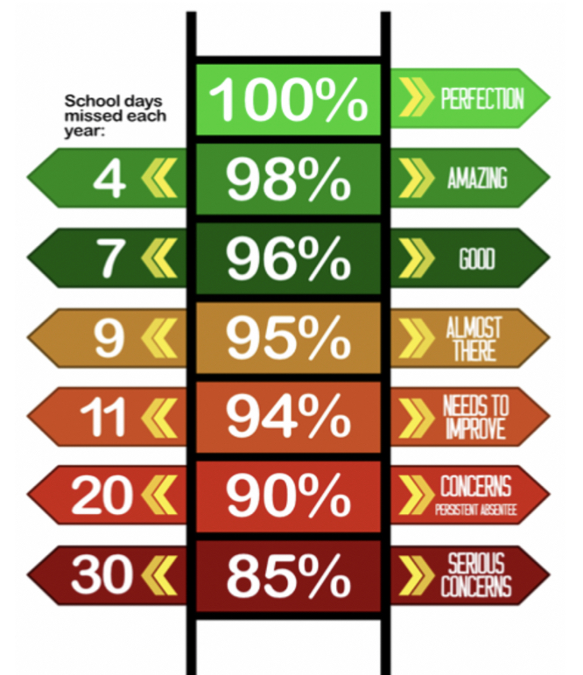**

**Y4 have the best attendance this week!**

Congratulations to Miss B Carvel who won £5.10 last week.

**We have raised £2930.00 so far.**

We have a new area we are fundraising for now and this is the area to the side of the trim trail. This will be an area dedicated to reflection, one that reaches our senses and provides an area of calmness and sanctuary.

**Happy birthday to all children celebrating their birthday this week! 🥳**

George D

Adelaide

Evie F

George D

Adelaide

Evie F

**Whole School:** 96 .6%

**Ladybirds:** 93.6%

**Year 1:** 94.3%

**Year 2:** 98.1%

**Year 3:** 96.4%

**Year 4:** 99.2%

**Year 5:** 96.6%

**Year 6:** 98%

**IT IS GOOD TO BE GREEN!**

COME ON WMG, WE NEED TO IMPROVE ATTENDANCE!

**WE ARE AIMING FOR 97%**

THE CLASS NEXT WEEK WITH THE BEXT ATTENDANCE GETS AN EXTRA PLAYTIME

**Why is high attendance important for your child’s education?**

**As a parent/carer you want the best life chances for your child/children. Being in school every day gives them the very best chance of achieving this. GCSE’S may seem a long way off for your child but 90% of children with average attendance at primary school and into secondary school of around 85% fail to achieve 5 or more GCSEs and one third of children fail to gain any.**

**Poor attendance in school will limit children’s ability to achieve their full potential and this will impact opportunities in life.**