

I hope you all had a lovely long bank holiday weekend. It has been so lovely this week for the children to return to the nice weather; they were so excited to finally be able to go onto the field at lunchtimes. Please remember that when the **weather** is like this, it is so important that the children have their water bottle in school with a sun hat and sun cream applied before school. Staff can not apply suncream.

I have noticed that this week with the change in weather that some children are wearing trainers on none PE days and that bracelets and other accessories from home are creeping in. Please ensure that **school shoes** are worn and that the only jewellery worn are small stud earrings. Bottle should contain water only and no other toys or accessories should be brought in from home.

Next week, year 6 will be sitting their **SATS** along with all of the other year 6 children across the country. The year 6 team have worked so hard in preparing the children this year and we are excited to see the children shine! We hope they have a fun weekend with nice early nights next week so they are as calm and prepared as possible! Good luck year 6!

Miss Crowther has written to you regarding the **KS1 bedtime story** session next Wednesday **(15th)** This is 5-6pm. This will be held outside with a campfire theme 🍃 🔥. PJ’s are encouraged to make sure the children are extra comfy. We will be having some special guest readers from school as well as your child’s class teacher or teaching assistant! We can’t wait to see you there.

On **Friday 17th May,** we are inviting all children to take part in **Mental Health Awareness Week** by wearing green to school.

The children will have some activities to complete throughout the week in their classes but on the Friday we will all raise awareness for Mental Health by wearing green instead of school uniform, like the green ribbon pins we can wear all year around.

Look forward to seeing you all dressed in green next Friday. 🧠💚

**Sports Day –**

KS2: 9am-12pm

KS1: 1pm-3pm

Everybody is welcome to attend to watch. We will have to ask you to leave during the lunch break however as we will not be able to accommodate anybody during this time whilst the children have lunch. Refreshments will be on sale to buy throughout the day.

Have a lovely weekend! Mrs Jones x

**Ladybirds -** Skylar and Shaiba

**Year 1** – Lucas

**Year 2** – Martha

**Year 4** – Euan

**Year 5** – Eva

**Year 6 -** Orson





**Leaderboard:**

Year 6

Year 3

Year 2

Year 4

Year 5

Year 1

**Top Mathstronauts:**

🥇 - Kyren S - Y3

🥈- Alfie A - Y6

🥉 - Mason S - Y6







**Leaderboard:**

Year 3

Year 2

Year 5

Year 6

Year 1

Year 4

**Top Spellers:**

🥇 - Kyren S - Y3

🥈- Gurseerat K - Y4

🥉 - Kyran S - Y4



**Congratulations to all of the children who have improved their rock speed this week!**

**Rock Hero (under 1 sec) -**

**Rock Legend (under 2 secs)-**

**Rock Star (under 3 secs)-**

**Headliner (under 4 secs) -**

**Support Act (under 5 secs)-**

**Breakthrough Artist (under 6 secs)-**

**Key Dates**

**May:**

**13th - 17th:** Y6 SATs week

**15th:** KS1 bedtime story 5-6pm

**20th-24th:** Health week

**23rd:** Sports day

**24th:** Last day of half term

**June:**

**3rd:** First day of Summer term

**5th:** Reception 2024 new intake meeting 6pm

**10th - 13th:** Book Fair in school

**19th:** PTA school disco

**20th:** Tamworth Schools Athletics Competition

**26th:** ATLP student awards

**July:**

**5th:** INSET day, school closed

**W/b 8th:** Reports out

**10th - 12th:** Y6 secondary transition days

**13th:** Summer Fair (12-3pm)

**19th:** Last day of term

**September:**

**2nd:** INSET day, school closed

**3rd:** INSET day, school closed

**4th:** First day of the autumn term for all children 20224





**Congratulations to all of our badge winners this week! 🤩**

**Bronze – Emilia G (Yr3)**

**Silver – Zachary, Lilly-May (Yr3) Tommy (Yr6)**

**Gold – Lottie, Jaxon (Yr3) Orson (Yr6)**

**Emerald – Adelaide, Lucas (Yr1) Alexander, Emilia P,**

**Bella (Yr3) Dakota, Ollie, Alexandra, Nevaeh (Yr4)**

**Holly, Charlotte (Yr6)**

**Ruby – Eliah, Ivy (Yr4)**



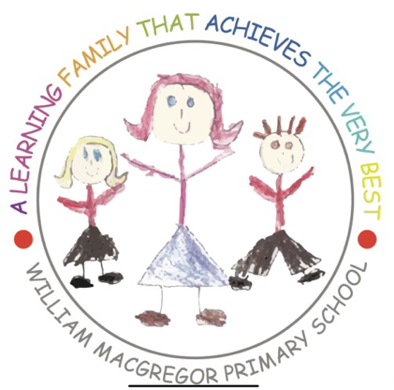******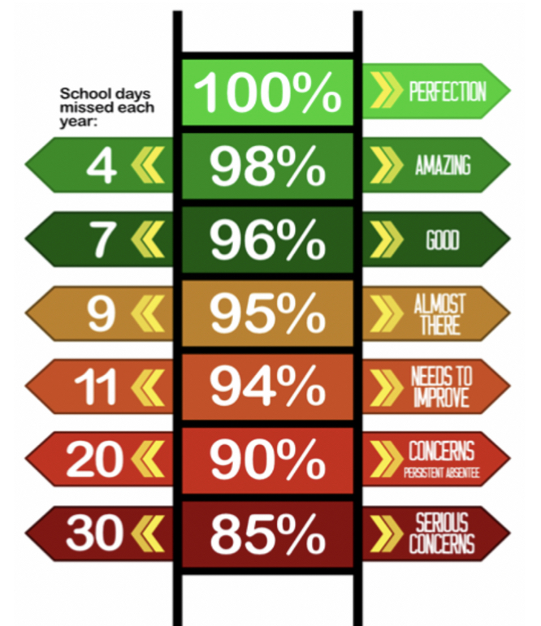**

**Y4 have the best attendance this week!**

Congratulations to Mrs C Fairfax-Haycox who won £5.10 last week.

**We have raised £2943.60 so far.**

We have a new area we are fundraising for now and this is the area to the side of the trim trail. This will be an area dedicated to reflection, one that reaches our senses and provides an area of calmness and sanctuary.

**Happy birthday to all children celebrating their birthday this week! 🥳**

Eden

Olly

Leia

Mason

**Whole School:** 94.3%

**Ladybirds:** 97.1%

**Year 1:** 91.7%

**Year 2:** 97.4%

**Year 3:** 90.7%

**Year 4:** 99.1%

**Year 5:** 88.4%

**Year 6:** 96%

**IT IS GOOD TO BE GREEN!**

COME ON WMG, WE NEED TO IMPROVE ATTENDANCE!

**WE ARE AIMING FOR 97%**

THE CLASS NEXT WEEK WITH THE BEXT ATTENDANCE GETS AN EXTRA PLAYTIME

**Why is high attendance important for your child’s education?**

**As a parent/carer you want the best life chances for your child/children. Being in school every day gives them the very best chance of achieving this. GCSE’S may seem a long way off for your child but 90% of children with average attendance at primary school and into secondary school of around 85% fail to achieve 5 or more GCSEs and one third of children fail to gain any.**

**Poor attendance in school will limit children’s ability to achieve their full potential and this will impact opportunities in life.**