

The biggest well done to all of our **year 6** this week having completed their SATs. They have worked very hard towards this and I was so proud of the way they approached the week and of all the effort they put into their success. A very big thank you to all of the staff involved too in helping year 6 prepare so well and who have helped in being able to give lots of different access arrangements. SATs week really is a huge team effort and I know the children are very thankful. Hopefully a very restful and sunny weekend to enjoy now after a slightly more relaxed day today.

A big thank you to Miss Crowther for organising a super **bedtime story** event this week. The children looked amazing in their pyjamas and enjoyed their relaxing hour of stories. Thank you to the staff who stayed late to read to the children too!

As Miss Sheward has already said, the children looked great today all in green to recognise and raise awareness for **mental health week.** Miss Sheward is about to complete her two day mental health lead training next month and we have some exciting plans for an introduction of a new ‘My Happy Mind’ curriculum in September. The children have already been practising some of the mindful breathing techniques in our weekly assemblies. Watch this space for more information.

On Thursday we will hopefully be able to have our annual **sports day.**  I have noted the times below. Spectators are of course welcome/encouraged but we cannot accommodate anybody over the lunch period. This event is weather dependent and as our field takes on so much water it is actually also dependent on the weather throughout the lead up. If we do need to postpone we will let you know via dojo. Hopefully we will be in for a lovely sunny day. Please can I ask that children have sun hats, water bottles and sun cream applied before school. Full school PE kit is to be worn with house colour t-shirts. **(KS2 9-12pm LB&KS1 1-3pm)**

To correspond with our sports day next week, **health week** will also take place Monday-Friday. This is a week to celebrate being healthy and educating the children on all the ways they can do this. Children are asked to come to school in proper school PE Kits each day. Please ensure this is smart. If school PE kits cannot be worn everyday if they need washing etc. then please ensure children are in their white school polo tops. All classes will begin the week with a tag rugby session, children will complete laps around the playground each morning, design healthy lunchbox and sports day posters and also learn the dangers of open water swimming in class sessions. This is particularly important for our chidlren as we are located and live by the canals and rivers. It is also ‘walk to school’ week so please try to park a little further away from school and walk or even walk all of the way to school from home. Chidren will be discussing healthy lunch boxes too. It will be a packed exciting week.

There are some quite nasty bugs going around at the moment. I have reattached the **NHS guidance** about how much time should be taken off from school. If children are sick or have had diarrhoea they need to be off school for 48 hours. Children can come to school with sore throats and coughs and we can administer Calpol with consent. Please keep encouraging them to wash their hands and use hand gel where possible.

Have a lovely weekend! Mrs Jones x

**Ladybirds -** Alexandru

**Year 1** – Isabella

**Year 2** – Joshua

**Year 3 -** Pearl/Zachary

**Year 4** – Kyran

**Year 5** – Isabella

**Year 6 -** All of Year 6





**Leaderboard:**

Year 3

Year 6

Year 5

Year 4

Year 2

Year 1

**Top Mathstronauts:**

🥇 - Alexander L - Y3

🥈- Freddie H - Y3

🥉 - Hei-Kai Y - Y6







**Leaderboard:**

Year 4

Year 2

Year 5

Year 6

Year 3

Year 1

**Top Spellers:**

🥇 - Archie A - Y2

🥈- Kyran S - Y4

🥉 - Gabriel T - Y6



**Congratulations to all of the children who have improved their rock speed this week!**

**Rock Hero (under 1 sec) -**

**Rock Legend (under 2 secs)-**

**Rock Star (under 3 secs)-**

**Headliner (under 4 secs) -**

**Support Act (under 5 secs)-**

**Breakthrough Artist (under 6 secs)-**

**Key Dates**

**May:**

**20th-24th:** Health week

**23rd:** Sports day

**24th:** Last day of half term

**June:**

**3rd:** First day of Summer term

**5th:** Reception 2024 new intake meeting 6pm

**10th - 13th:** Book Fair in school

**19th:** PTA school disco

**20th:** Tamworth Schools Athletics Competition

**26th:** ATLP student awards

**July:**

**4th:** Ladybirds graduation 2.30pm

**5th:** INSET day, school closed

**W/b 8th:** Reports out

**10th - 12th:** Y6 secondary transition days

**13th:** Summer Fair (12-3pm)

**18th:** Year 6 production at QEMS 6pm

**19th:** Last day of term

**September:**

**2nd:** INSET day, school closed

**3rd:** INSET day, school closed

**4th:** First day of the autumn term for all children 20224

**October:**

**25th:** Last day of half term





**Congratulations to all of our badge winners this week! 🤩**

**Bronze – Ralph, Emilia, Alexandru, Sahiba, Mia, Nikodem (LB)**

**Silver – Lucy, Florence (LB) Olivia (Yr3) Kaycee (Yr6)**

**Gold – Pearl, Brooke, Freddie (Yr3) Chase, Ella Ro (Yr5)**

**Emerald – Clara (Yr1) Mia, Archie A (Yr2) Skyler, Lucas (Yr3)**

**Noah, Sylvia, Brody, James, Lexi (Yr5)**

**Ruby – Katherine (Yr3) Isla (Yr6)**



******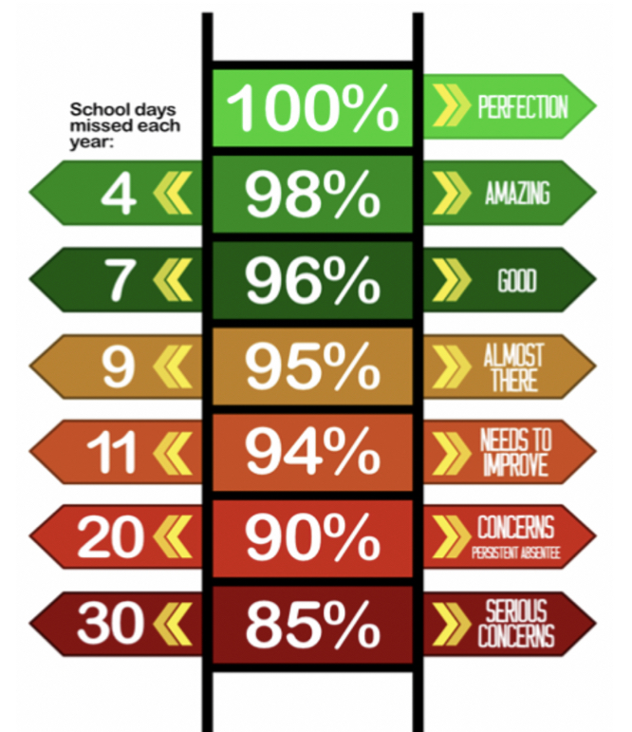**

**Y6 have the best attendance this week!**

Congratulations to Mrs S Norton who won £5.10 last week and has very kindly donated this back to school.

Thank you.

**We have raised £2950.40 so far.**

We have a new area we are fundraising for now and this is the area to the side of the trim trail. This will be an area dedicated to reflection, one that reaches our senses and provides an area of calmness and sanctuary.

**Happy birthday to all children celebrating their birthday this week! 🥳**

Robert

Noor

Sameena

Jacob H

**Whole School:** 94.3%

**Ladybirds:** 91%

**Year 1:** 95.7%

**Year 2:** 90%

**Year 3:** 97.4%

**Year 4:** 95.2%

**Year 5:** 91.7%

**Year 6:** 98.9%

**IT IS GOOD TO BE GREEN!**

COME ON WMG, WE NEED TO IMPROVE ATTENDANCE!

**WE ARE AIMING FOR 97%**

THE CLASS NEXT WEEK WITH THE BEXT ATTENDANCE GETS AN EXTRA PLAYTIME

**Why is high attendance important for your child’s education?**

**As a parent/carer you want the best life chances for your child/children. Being in school every day gives them the very best chance of achieving this. GCSE’S may seem a long way off for your child but 90% of children with average attendance at primary school and into secondary school of around 85% fail to achieve 5 or more GCSEs and one third of children fail to gain any.**

**Poor attendance in school will limit children’s ability to achieve their full potential and this will impact opportunities in life.**