

**Welcome** back to our last half term of the school year. It has already been a very busy week in school and this really sets the president for the coming weeks. Please keep a really close eye on dojo and the school calendar for dates of end of year events. There is still so much teaching and learning to happen so please ensure children are in school each day, well prepared and presented as normal.

We can begin the new school year with some exciting staff news. A very big congratulations to **Mrs Bailey** and her husband who are expecting their first baby in December. We are very excited for them as I know the children are who Mrs bailey told this week.

This week we have began to welcome **‘Action for Children’** in school who are a team within the Staffordshire Emotional Well-being service. Our younger children had some great sessions this week and they will be back to deliver even more sessions with the rest of the school in coming weeks.

**A few reminders of things to action:**

* Please book for Father’s Day breakfast for your child/children and their special person. All on MCAS. Choose a day and book number of places (including children – 1 adult per family). Choice of sausage baps and a vegetarian option at £1.20 each.
* Download the ‘Safer Schools’ App. This is a new app and will really help keep you up to date with online risks and knowledge.
* Last day today for children’s university hours to be logged for this academic year.

We will try again for **sports day** on Friday (14th June) which again is weather dependent. **KS2: 9am-12pm KS1 and Ladybirds: 1-3pm.** All are welcome to attend. A reminder that we will need to ask you to leave the premises for lunch.

**Book Fair** is in school next week and we will hopefully set up after school on the main playground. I know that Miss Crowther has sent out lots of information on this so we look forward to seeing you there. A large percentage of money from the books purchased comes back to school so we can buy books for our class library for our children to enjoy.

Just a reminder please that our school **car park** should not be used as a walkway from one side of the school to the other as this is a danger. Please use the outside path to walk around.

As we continue to be stretched **financially** with the general cost of living expenses, I have attached lots of help and support of different things available that you may be able to claim. Please come and see us too if you are in need of a Foodbank voucher as we hold these in school and these can be given out every 3 weeks.

Mrs Jones x

**Ladybirds -** Mia & Florence

**Year 1** – Reuben

**Year 2** – Billy

**Year 3 -** Lilly-may

**Year 4** – Sophie

**Year 5** – Akshaj

**Year 6 -** Jenson





**Leaderboard:**

Year 3

Year 5

Year 4

Year 2

Year 1

Year 6

**Top Mathstronauts:**

🥇 - Katherine B - Y3

🥈- Freddie H - Y3

🥉 - Livy P - Y5







**Leaderboard:**

Year 3

Year 4

Year 2

Year 5

Year 1

Year 6

**Top Spellers:**

🥇 - Bella H - Y3

🥈- Archie A - Y2

🥉 - Kyren S - Y3



**Congratulations to all of the children who have improved their rock speed this week!**

**Rock Hero (under 1 sec) -**

**Rock Legend (under 2 secs)-**

**Rock Star (under 3 secs)-**

**Headliner (under 4 secs) -**

**Support Act (under 5 secs)-**

**Breakthrough Artist (under 6 secs)-**

**Key Dates**

**June:**

**10th - 13th:** Book Fair in school

**14th June:** Rearranged sports day

**19th:** PTA school disco

**20th:** Tamworth Schools Athletics Competition

**25th-28th:** Fathers Day breakfast 8am

**26th:** ATLP student awards

& Year 3 music share at Cathedral

**28th:** Year 5 ukelele concert

**July:**

**2nd:** Children’s university bronze and silver gradation in school 1.45pm

**3rd:** Learning showcase afternoon 1.15pm

**4th:** Closed for polling day

**5th:** INSET day, school closed

**W/b 8th:** Reports out

**10th - 12th:** Y6 secondary transition days

**12th:** Moving up morning

**13th:** Summer Fair (12-3pm)

**18th:** Year 6 production at QEMS 6pm

**19th:** Last day of term

**September:**

**2nd:** INSET day, school closed

**3rd:** INSET day, school closed

**4th:** First day of the autumn term for all children 20224

**October:**

**25th:** Last day of half term





**Congratulations to all of our badge winners this week! 🤩**

**Bronze – Adlee (LB)**

**Silver – Darcy, Max, Skylar, Robert, James (LB)**

**Gold – Delaney, Arlie (Yr2)**

**Emerald – James (Yr1) Martha (Yr2) Lewis (Yr4) Ava (Yr5)**

**Alfie A (Yr6)**

**Ruby – Cora (Yr1) Kyran (Yr3)**



******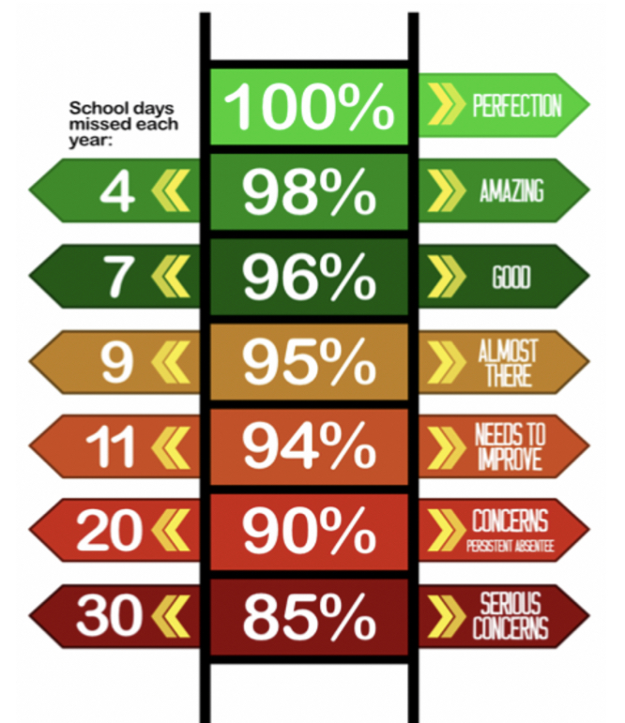**

Congratulations to Mrs C Fairfax-Haycox who won £5.10 last week.

**We have raised £2970.80 so far.**

We have a new area we are fundraising for now and this is the area to the side of the trim trail. This will be an area dedicated to reflection, one that reaches our senses and provides an area of calmness and sanctuary.

**Y5 have the best attendance this week!**

**Happy birthday to all children celebrating their birthday this week! 🥳**

Cora

Dakota

Theo S

Freddie B

**Whole School:** 96%

**Ladybirds:**95.2%

**Year 1:** 94.8%

**Year 2:** 94.6%

**Year 3:** 98.2%

**Year 4:** 94.7%

**Year 5:** 99.6%

**Year 6:** 94.9%

**IT IS GOOD TO BE GREEN!**

COME ON WMG, WE NEED TO IMPROVE ATTENDANCE!

**WE ARE AIMING FOR 97%**

THE CLASS NEXT WEEK WITH THE BEXT ATTENDANCE GETS AN EXTRA PLAYTIME

**Why is high attendance important for your child’s education?**

**As a parent/carer you want the best life chances for your child/children. Being in school every day gives them the very best chance of achieving this. GCSE’S may seem a long way off for your child but 90% of children with average attendance at primary school and into secondary school of around 85% fail to achieve 5 or more GCSEs and one third of children fail to gain any.**

**Poor attendance in school will limit children’s ability to achieve their full potential and this will impact opportunities in life.**