

Mrs Jones x

**Ladybirds -**

**Year 1** –

**Year 2** –

**Year 3 -**

**Year 4** –

**Year 5** –

**Year 6 -**





**Leaderboard:**

Year

Year

Year

Year

Year

Year

**Top Mathstronauts:**

🥇 -

🥈-

🥉 -







**Leaderboard:**

Year

Year

Year

Year

Year

Year

**Top Spellers:**

🥇 -

🥈-

🥉 -



**Congratulations to all of the children who have improved their rock speed this week!**

**Rock Hero (under 1 sec) -**

**Rock Legend (under 2 secs)-**

**Rock Star (under 3 secs)-**

**Headliner (under 4 secs) -**

**Support Act (under 5 secs)-**

**Breakthrough Artist (under 6 secs)-**

**Key Dates**

**June:**

**19th:** PTA school disco

**20th:** Tamworth Schools Athletics Competition

**25th-28th:** Fathers Day breakfast 8am

**26th:** ATLP student awards

& Year 3 music share at Cathedral

**28th:** Year 5 ukelele concert

**July:**

**2nd:** Children’s university bronze and silver gradation in school 1.45pm

**3rd:** Learning showcase afternoon 1.15pm

**4th:** Closed for polling day

**5th:** INSET day, school closed

**W/b 8th:** Reports out

**10th - 12th:** Y6 secondary transition days

**12th:** Moving up morning

**13th:** Summer Fair (12-3pm)

**18th:** Year 6 production at QEMS 6pm

**19th:** Last day of term

**September:**

**2nd:** INSET day, school closed

**3rd:** INSET day, school closed

**4th:** First day of the autumn term for all children 20224

**October:**

**25th:** Last day of half term





**Congratulations to all of our badge winners this week! 🤩**

**Silver – Charlie, Eden, Luca (LB) Leia (Yr5)**

**Gold – Archie (Yr3)**

**Emerald – Isabelle (Yr3) Isabella, Chloe, Alex,**

**Stefi (Yr5) Jacob (Yr6)**

**Ruby – Louis (Yr5)**

**Children will receive these badges during assembly next week.**



******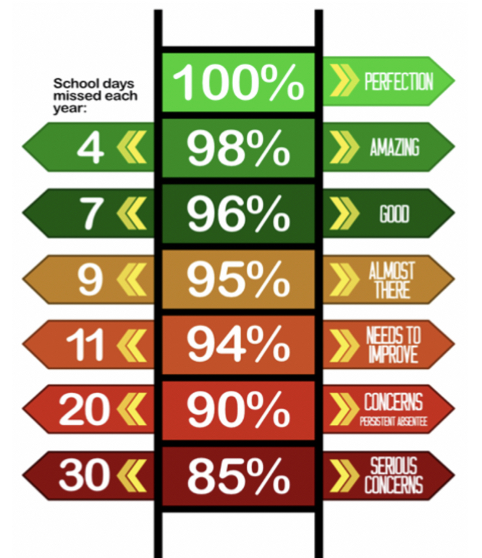**

Congratulations to Ms L Jones who won £5.10 last week.

**We have raised £2977.60 so far.**

We have a new area we are fundraising for now and this is the area to the side of the trim trail. This will be an area dedicated to reflection, one that reaches our senses and provides an area of calmness and sanctuary.

**Y5 have the best attendance this week!**

**Happy birthday to all children celebrating their birthday this week! 🥳**

Miles

**Whole School:**

**Ladybirds:**

**Year 1:**

**Year 2:**

**Year 3:**

**Year 4:**

**Year 5:**

**Year 6:**

**IT IS GOOD TO BE GREEN!**

COME ON WMG, WE NEED TO IMPROVE ATTENDANCE!

**WE ARE AIMING FOR 97%**

THE CLASS NEXT WEEK WITH THE BEXT ATTENDANCE GETS AN EXTRA PLAYTIME

**Why is high attendance important for your child’s education?**

**As a parent/carer you want the best life chances for your child/children. Being in school every day gives them the very best chance of achieving this. GCSE’S may seem a long way off for your child but 90% of children with average attendance at primary school and into secondary school of around 85% fail to achieve 5 or more GCSEs and one third of children fail to gain any.**

**Poor attendance in school will limit children’s ability to achieve their full potential and this will impact opportunities in life.**