C:\Users\L.Fitzpatrick\AppData\Local\Microsoft\Windows\INetCache\Content.MSO\F586F9D0.tmp

Ladybirds – Rebecca

Year 1 – Dixie

Year 2 – Luna

Year 3 – Stefi

Year 4 – Seb

Year 5 – Brodi

Year 6 – Harvey

**News…**

We are pleased that we have managed to rearrange our **open morning** for parents who have children starting school next September. This will take place on **Tuesday 23rd November at 9am**. Please spread the word amongst friends and family for anyone who this applies to. We will ensure all adults visiting the school will be wearing a mask.

Further great news – **Miss Cumiskey** had her little girl last Thursday morning. Both mum and Lorena are home from hospital and settling into family life well. **Mrs Wallace** also joined our lunchtime team this week. She’s had a lovely first few days getting to know the children and staff.

So we can run **Christmas Craft morning** as safely as possible we have decided to separate the sessions so we only have once class’s parents in school at any one time. We will use the school hall and spread out. Days and times for these sessions are:

Tuesday 7th December 9-10.15am Yr6 AND 10.45-12.00 Yr5

Friday 10th December 9-10.15am Yr3 AND 10.45-12.00 Yr4

Monday 13th December 9-10.15am Yr2

Tuesday 14th December 9-10.15am Yr1 AND 10.45-12.00 LB

We only have space for one family member per child and please wear a face mask when in school.

On **Friday it is Children in Need** day. We do not usually take part in this fund raising event, but we are happy for the children can come to school wearing their Pudsey clothing/accessories. If you want to make a donation, we will ensure this is sent to Children in Need.

Next week is **anti-bullying week** with the theme of **‘One Kind Word’** Children will be completing some additional work to their PSHE work in class highlighting the need to be kind to all. On **Monday**, to celebrate our differences we will be taking part in the national **‘Odd Sock Day.’** Children can come to school in their craziest odd socks for the day.

The children may come home this evening asking to design some **‘Angel Wings’** this is a project for the town over the Christmas period. (More information below). All designs to be back to school by Wednesday.

**Congratulations to all bronze badge winners this week.**

**Bronze**

**Y1** – Dylan **Y4** – Jacob, Seb & Jack **Y5** – Millie, Ellie-Mae, Henry, Megan, Eliza

**Silver**

**Y1** – Alexander, Emelia P, Ted, Lucas, Pearl, Olivia, Bella & Brooke **Y2** – Charlie, Eliah, Lily, Teddy, Evie, Kryan, Ollie, Euan, Ivy, Nevaeh, Roo, Darcy, Isabelle, Maggie & Sophie **Y3** – Ella R, Sarah, James & Ella Ro **Y4** – Theo, Victoria, Isla, Kia & Kitty

**Gold**

**Y1** – Martynas & Katherine **Y5** –Stuie & Aida

**This week’s MacGregor Mile Winners are Year 5**

**Running 63 miles**

**Birthday celebrations!**

**Jenson**

**Andrei**

**Mia M**

**Isabelle Cl**

**Roo**



👫 Every week, there will be a battle in each class. Boys VS. Girls. 👫

Good luck! 🤞🏼

**This week’s most valuable players:**

**Year 2: Luna & Emi 🥇**

**Year 3: James & Gracie 🥇**

**Year 4:Charlotte & Kai-Hei 🥇**

**Year 5: Megan & Alex 🥇**

**Year 6: Harvey & Szeki 🥇**



**Leaderboard this week:**

Year 3

Year 4

Year 2

Year 5

Year 1

Year 6

**Top Spellers:**

**🥇 -Sarah Y – Y3**

**🥈 – Leart G Y3**

**🥉 – Noah H – Y3**



**Leaderboard this week:**

Year 2

Year 4

Year 3

Year 5

Year 1

Year 6

**Top Mathstronauts:**

**🥇 - Nevaeh – Y2**

**🥈 – Orson W– Y4**

**🥉 – James B – Y3**

**School events**

Reminder that our school website has all events taking place in school. [www.williammacgregor.staffs.sch.uk](http://www.williammacgregor.staffs.sch.uk)

**November**

15th Odd sock day

22nd—25th Book Fair

24th PTFA Annual General Meeting 6pm at school

29th Staff training day

**December**

1st PTFA Film night -details to follow

7th Yr6 Christmas Craft 9-10.15am

Yr5 Christmas Craft 10.45-12

9th Yr1 and Yr2 nativity at St.Editha’s church. 6pm

10th Ladybirds nativity at Elim Church 9am

10th Yr3 Christmas Craft 9-10.15am

Yr4 Christmas Craft 10.45-12

13th Yr2 Christmas Craft 9-10.15am

14th Yr1 Christmas Craft 9-10.15am

LB Christmas Craft 10.45-12

14th Parent consultation meetings 1.30pm-6.30pm

15th Christmas lunch

16th PTFA School discos

17th Whole school carol service at St.Editha’s 2pm

End of autumn 2

**January**

4th staff training day

5th start of spring 1

**Fundraising – School lottery fortnightly update**

Congratulations to Mrs K Hadley who won £13.20 last week. Mrs Hadley as kindly donated her winnings back to the school.

We have raised £ 1569.20 so far.

We have a new area we are fund raising for now and this is the area to the side of the trim trail. We would like to put artificial grass here and develop a calm area where the children can relax.



In school 22nd-25th November

**PARENTS CONSULTATION APPOINTMENTS 14th December**

On Tuesday 14th we are holding our autumn term parent consultations. We found holding parents’ consultations over the phone equally as effective at communicating with you as we did face to face. For this reason (and also for increased safety measures and convenience for parents) we are offering parents the opportunity to meet either face to face or to talk over the phone. Appointments are available between 1.30pm and 6.30pm. Appointments will be available to book on MYCAS from Monday morning. You will receive a notification.

**Please note, we are only able to hold face to face meetings in school once the children have left school at 3.30pm. We will assume all bookings made are for over the phone appointments. If you would prefer a face to face meeting, please message your child’s class teacher on DoJo to request a face to face meeting at the time you have booked on MYCAS.**

It is very important that you make an appointment with your child’s class teacher.

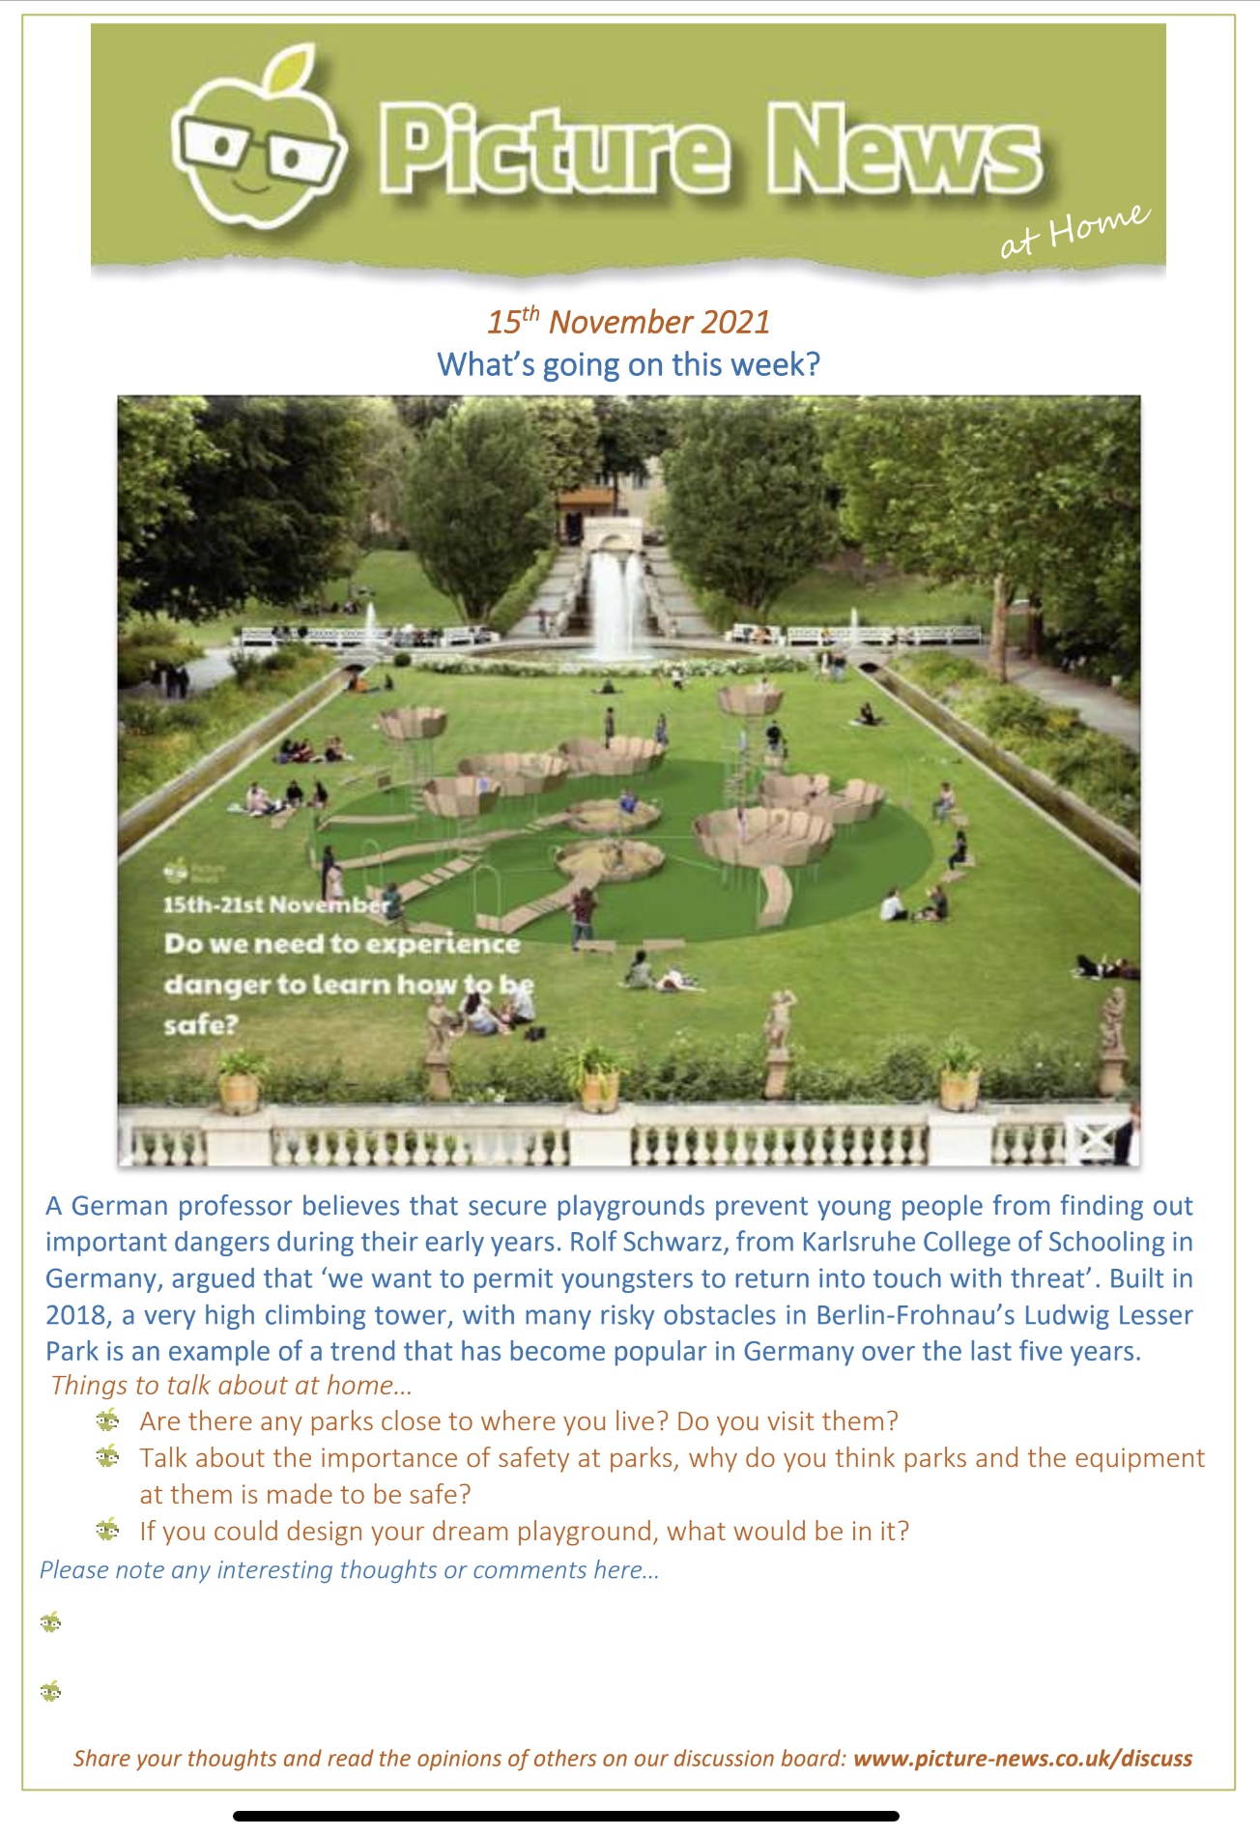**Next week’s assembly topic. Please use this information to discuss this as a family at home. I am sure it will bring about great discussions!**

