

Ladybirds – Lola-May

Year 1 – Zachary

Year 2 – Liliana

Year 3 – Livy

Year 4 – Jack

Year 5 – Harper

Year 6 – Bradley

PE Stars of the Week

Zac & Elijah (LB)

**News…**

**COVID** – I am sure you are aware that Tamworth COVID cases remain one of the highest in the country. We must continue to protect ourselves and each other by testing ourselves with LFD twice a week and if you develop symptoms, book a PCR test immediately. We have two children who are currently isolating (one in Yr3 and one in Yr6) and now a staff member (Yr4). I have put the latest guidance on the next page for your information. Children do not need to isolate (even if they have been in close contact) unless they develop symptoms. Adults who have been vaccinated also do not need to isolate unless they have symptoms. Please can I urge off adults to test twice a week.

**Change of date** – just to remind you that Academy photos are now in Tuesday next week (5th), not on Monday.

It is imperative that the school office has all **asthma forms** returned and your child’s inhaler in school. Please complete and return these as a matter of urgency.

**Birthday celebrations!**

Layla

Chace

Kyrah

Archie H

Lola - Mae

Gracie - Mae

Bradley



👫 Every week, there will be a battle in each class. Boys VS. Girls. 👫

Good luck! 🤞🏼

**This week’s most valuable players:**

**Year 2: Nevaeh & Eliah 🏅**

**Year 3: George & Stefi**

**Year 4: Jack & Victoria 🥇**

**Year 5: Aida & Ronnie 🥇**

**Year 6: Harvey & Szeki 🥇**



**Leaderboard this week:**

Year 5

Year 2

Year 4

Year 3

Year 6

Year 1

**Top Spellers:**

**🥇 - Aida O – Y5**

**🥈 – Slyvia L – Y3**

**🥉 – Andrei O – Y6**

**Fundraising – School lottery fortnightly update**

Congratulations to Mrs C Fairfax- Haycox who won £12.90 last week.

We have raised £1464.40 so far.

We have a new area we are fund raising for now and this is the area to the side of the trim trail. We would like to put artificial grass here and develop a calm area where the children can relax.

**Last week’s MacGregor Mile Winners were Year 3**





**Leaderboard this week:**

Year 6

Year 2

Year 4

Year 5

Year 3

Year 1

**Top Mathstronauts:**

**🥇 - Andrei O – Y6**

**🥈 – Charlotte H – Y4**

**🥉 – Sophie – Y2**

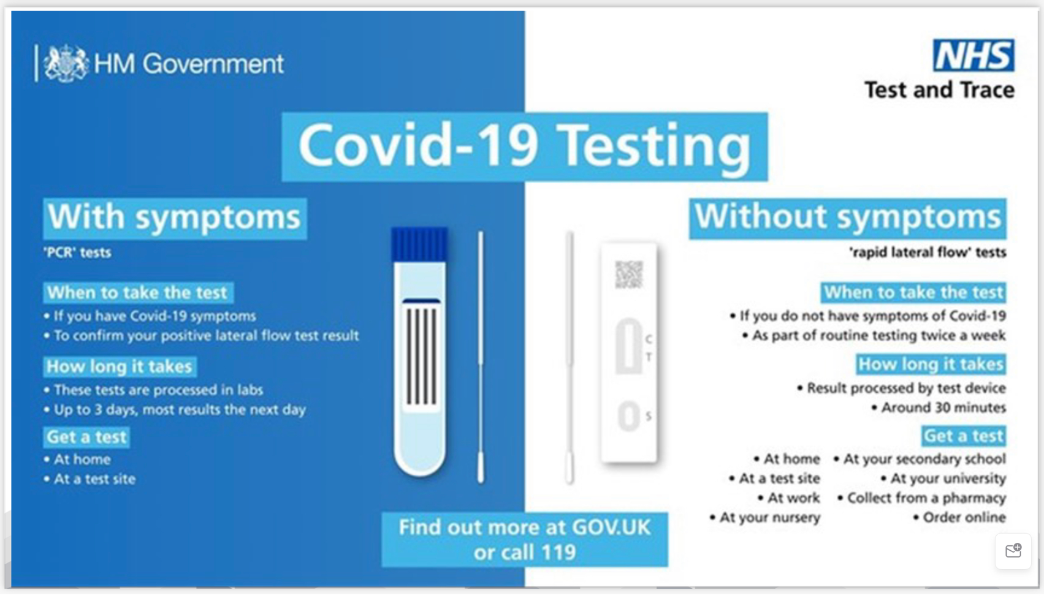

**School events**

Reminder that our school website has all events taking place in school. [www.williammacgregor.staffs.sch.uk](http://www.williammacgregor.staffs.sch.uk)

**October**

5th School Photos ( Change of date)

12th Harvest festival at St.George’s church. This is for the children only.

21st end of autumn 1

22nd staff training day

25th-29th half term week

**November**

1st start of autumn 2

**December**

9th Yr1 and Yr2 nativity at St.Editha’s church. 6pm

10th Ladybirds nativity at Elim Church 9am

13th Christmas craft morning 8.45-10.15am (one parent/relative per child)

14th Parent consultation meetings 2-7pm

15th Christmas lunch

17th Whole school carol service at St.Editha’s 2pm

End of autumn 2

**January**

4th staff training day

5th start of spring 1

**Assembly Topic next week**



