Ladybirds – Maya
Year 1 – Lily-May
Year 2 – Isabelle
Year 3 – Chace
Year 4 – Tamzin
Year 5 – Tayla
Year 6 – Miley

News…
We held our first PTFA meeting this week with Kate and the team of core members of our PTFA. It has been a real struggle these past 2 academic years to hold fundraising events, but we are hoping to return to some normality this term. We will be holding our AGM meeting on Wednesday 24th November at 6pm in school. At this AGM, agenda items will include voting in key roles like, the chair, treasurer and secretary. If you are interested in any of these roles, please get in touch with me and I will pass this onto Kate. Any nominations for these roles must be given in advance and be seconded. We will also be discussing events for the academic year and how these may be adapted considering COVID safety. All parents are welcome at this meeting, as well as other relatives to children who attend William MacGregor. We have already planned a film night on the 1st December and a school disco on Thursday 16th December. Further details will follow.
Today we said a sad farewell to Mrs Hobbs – we are all going to miss her hugely. We wish her the very best as she starts her new career working with adults. We successfully appointed Mrs Welsby to replace Mrs Hobbs. She will be starting with us on the 18th November and we really look forward to welcoming her to our team.
As you know, in 2022, the May Spring Bank Holiday will be moved to Thursday 2nd June and an additional Bank Holiday on Friday 3rd June will create a four-day weekend to help celebrate the Queen’s Platinum Jubilee. School is closed for half term on these dates, so county councils have added this extra day onto the end of the academic year. Our summer term will now end on Thursday 21st July 2022.
Please can I remind parents and relatives that dogs are not allowed on the school site unless they are to assist people who are registered with a disability (guide dog). This includes young puppies. Many thanks.

Congratulations to all bronze badge winners this week.
Bronze
Y1 – Skyler
Y2 – Isabella & Keanan
Silver –
Y2 – Molly, Lewis & Liliana
Y3 – Livy
Y4 – Lily
Y5 – Joseph, Rosie AR, Milo, Alex & Mollie

This week’s MacGregor Mile Winners are Year 4

Running 74 miles

Birthday celebrations!
Billy
Leart
Lucas
Finn

Every week, there will be a battle in each class. Boys VS. Girls.
Good luck!

This week’s most valuable players:
Year 2: Luna & Emi
Year 3: Gracie & James
Year 4: Jack & Charlotte
Year 5: Alexia & Stuie
Year 6: Harvey & Szeki

Leaderboard this week:
Year 3
Year 4
Year 5
Year 2
Year 6
Year 1
Top Spellers:
- Sarah T – Y3
– Tommy – Y4
– James B – Y3

Leaderboard this week:
Year 2
Year 4
Year 6
Year 5
Year 3
Year 1
Top Mathstronauts:
- Nevaeh – Y2
– Andrei O – Y6
– Orson – Y4

School events
Reminder that our school website has all events taking place in school. www.williammacgregor.staffs.sch.uk

November
24th PTFA Annual General Meeting 6pm at school
29th Staff training day
December
1st PTFA Film night -details to follow
9th Yr1 and Yr2 nativity at St.Editha’s church. 6pm
10th Ladybirds nativity at Elim Church 9am
13th Christmas craft morning 8.45-10.15am (one parent/relative per child)
14th Parent consultation meetings 2-7pm
15th Christmas lunch
16th PTFA School discos
17th Whole school carol service at St.Editha’s 2pm
End of autumn 2

January
4th staff training day
5th start of spring 1
Fundraising – School lottery fortnightly update
Congratulations to Dr H Dennis who won £13.20 last week.
We have raised £ 1551.60 so far.
We have a new area we are fund raising for now and this is the area to the side of the trim trail. We would like to put artificial grass here and develop a calm area where the children can relax.

Ladybirds  Lola  Archie A  Mason | Year 3  James  Noah  Eva | Year 6  Lily  Tyler  Ellie-Mae
Year 1  Pearl  Brooke  Willow | Year 4  Alfie M  Mia  Holly
Year 2  Lewis  Kyran  Darcy | Year 5  Max  Alexia  Jaiha

MacGregor Mile Winners for Autumn 1

Next week’s assembly topic. Please use this information to discuss this as a family at home. I am sure it will bring about great discussions!

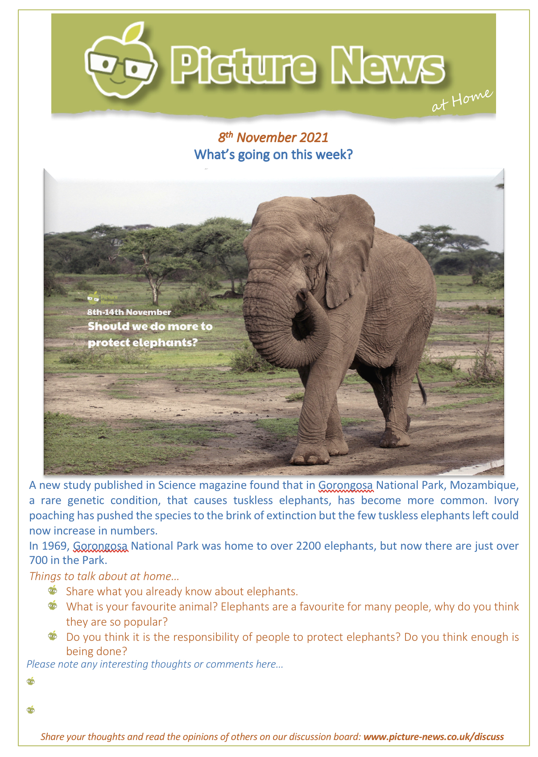

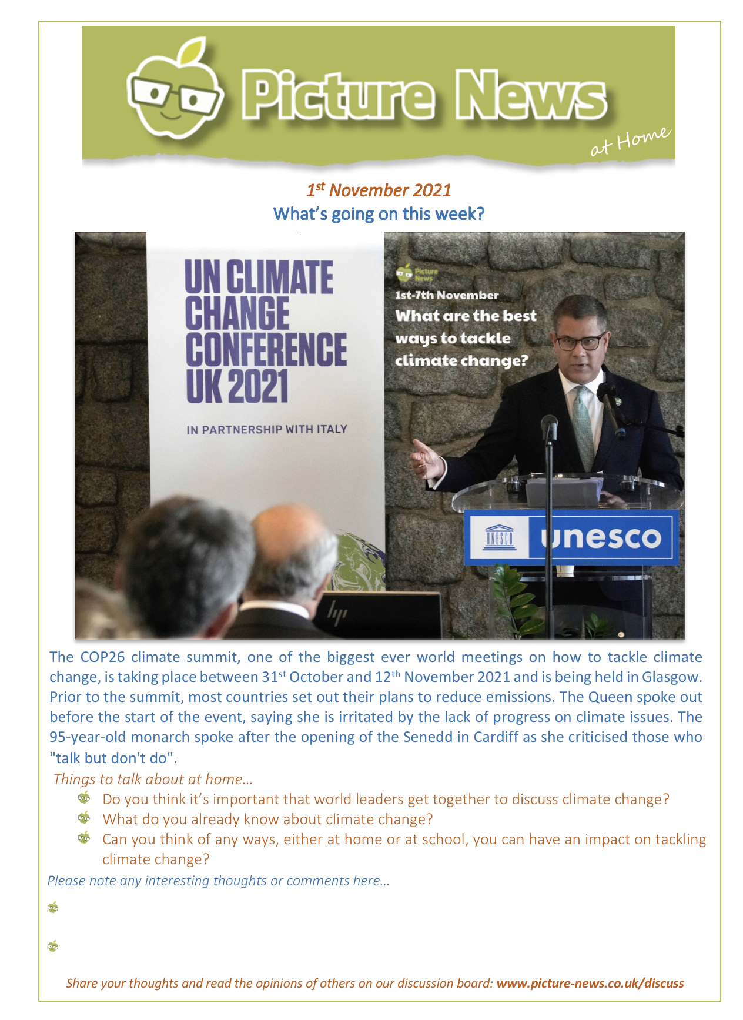
This week our assembly theme was about the UN’s Climate Change Conference which Is being held over the next two weeks.This will also raise some interesting discussions in the home.

