

Today we finish school after another half term. The children have yet again showed great learning behaviours this term and accessed a wealth of school activities on offer to them. It is almost unbelievable that we are entering our last half term of the school year; the best but busiest! Please keep a close eye on dojo and the school calendar dates for all the school events that are taking place next term.

We have had a really successful **‘health week’** in school this week despite the torrential rain on Wednesday putting a stop to our sports day! The children have loved coming in completing their laps of the school playground and doing some more ‘wake up shake up’ activities in the hall or their classrooms. Hopefully some of you have taken part in walking to school too. A wonderful week of learning had by all including a tag rugby day!

This week children have all had a new app installed on their ipad – **‘Gratitude journal’.** This allows the children to log things daily that they are grateful for and positives from their day that they want to remember. This app keeps a log of those in their jar and then they go back in and read these whenever they need it. This really allows the children to think in a positive way. They can continue this over the holidays.

A big well done to our **Tag Rugby** team this week who took part in a tournament at Tamworth Rugby club. They did really well especially as this was the first time for many competing in this sport. Thank you to Mrs McNerlin for arranging it and coaching the children whilst there.

As you will have seen on the news this week, we will be undertaking a **general election on Thursday 4th July.** This means that we will be closed to be used as a polling station on that day. We also then have an INSET day on Friday 5th July. School will be closed for all children on these two days. Staff will use this time for professional development.

Have a lovely bank holiday weekend and half term whatever you may be doing.

Please see the attached documents if you need support over the half term holiday.

Mrs Jones x

**Ladybirds -** Anika & Lola

**Year 1** – Myra

**Year 2** –

**Year 3 -**

**Year 4** – Olivia

**Year 5** – Ella Rose

**Year 6 -** Ella





**Leaderboard:**

Year 3

Year 4

Year 2

Year 6

Year 5

Year 1

**Top Mathstronauts:**

🥇 - Freddie H - Y3

🥈- Liliana D - Y3

🥉 - Kyren S - Y3







**Leaderboard:**

Year 2

Year 3

Year 4

Year 5

Year 1

Year 6

**Top Spellers:**

🥇 - Archie A - Y2

🥈- Ana T - Y2

🥉 - Kyran S - Y4



**Congratulations to all of the children who have improved their rock speed this week!**

**Rock Hero (under 1 sec) -**

**Rock Legend (under 2 secs)-**

**Rock Star (under 3 secs)-**

**Headliner (under 4 secs) -**

Charlie

**Support Act (under 5 secs)-**

**Breakthrough Artist (under 6 secs)-**

**Key Dates**

**June:**

**3rd:** First day of Summer term

**5th:** Reception 2024 new intake meeting 6pm

**10th - 13th:** Book Fair in school

**14th June:** Rearranged sports day

**19th:** PTA school disco

**20th:** Tamworth Schools Athletics Competition

**26th:** ATLP student awards

& Year 3 music share at Cathedral

**28th:** Year 5 ukelele concert

**July:**

**4th:** Closed for polling day

**5th:** INSET day, school closed

**W/b 8th:** Reports out

**10th - 12th:** Y6 secondary transition days

**12th:** Moving up morning

**13th:** Summer Fair (12-3pm)

**18th:** Year 6 production at QEMS 6pm

**19th:** Last day of term

**September:**

**2nd:** INSET day, school closed

**3rd:** INSET day, school closed

**4th:** First day of the autumn term for all children 20224

**October:**

**25th:** Last day of half term





**Congratulations to all of our badge winners this week! 🤩**

**Bronze – Sophia, Akshian (LB)**

**Silver – Lola-Rose, Arabella, Alannah (LB) Joshua (Yr3)**

**Burak (Yr5)**

**Gold – Ellison, Layla (Yr3) Max (Yr5)**

**Emerald – Willow (Yr3) Charlie, Mally (Yr4) Ella Ra,**

**Leart (Yr5)**

**Ruby – Martynas (Yr3) Alisha, Tamzin (Yr6)**



******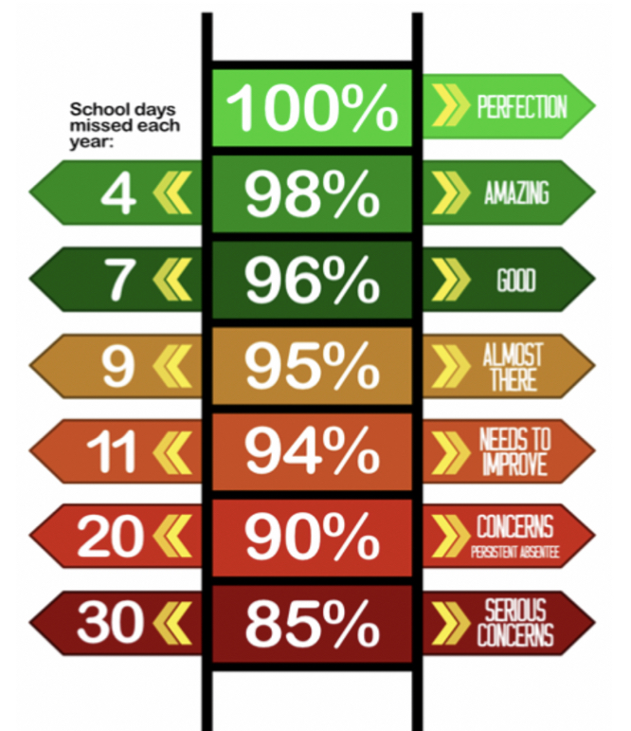**

**Y have the best attendance this week!**

Congratulations to Mr A Fellows who won £5.10 last week and has very kindly donated this back to school.

Thank you.

**We have raised £2957.0 so far.**

We have a new area we are fundraising for now and this is the area to the side of the trim trail. This will be an area dedicated to reflection, one that reaches our senses and provides an area of calmness and sanctuary.

**Happy birthday to all children celebrating their birthday this week! 🥳**

Carter M

Lili

Thomas H

Izzy

Lilly-May

Darcy

Emelia

Stefi

**Whole School:**

**Ladybirds:**

**Year 1:**

**Year 2:**

**Year 3:**

**Year 4:**

**Year 5:**

**Year 6:**

**IT IS GOOD TO BE GREEN!**

COME ON WMG, WE NEED TO IMPROVE ATTENDANCE!

**WE ARE AIMING FOR 97%**

THE CLASS NEXT WEEK WITH THE BEXT ATTENDANCE GETS AN EXTRA PLAYTIME

**Why is high attendance important for your child’s education?**

**As a parent/carer you want the best life chances for your child/children. Being in school every day gives them the very best chance of achieving this. GCSE’S may seem a long way off for your child but 90% of children with average attendance at primary school and into secondary school of around 85% fail to achieve 5 or more GCSEs and one third of children fail to gain any.**

**Poor attendance in school will limit children’s ability to achieve their full potential and this will impact opportunities in life.**