Music development plan summary:
William MacGregor Primary School

Overview
Detail | Information
Academic year that this summary covers | September 2024 – July 2025
Date this summary was published | July 2024
Date this summary will be reviewed | July 2025
Name of the school music lead | Zoe Tuton
Name of local music hub | Entrust Staffordshire

This is a summary of how our school delivers music education to all our pupils across three areas – curriculum music, extra-curricular provision and musical experiences – and what changes we are planning in future years. This information is to help pupils and parents or carers understand what our school offers and who we work with to support our pupils’ music education.

Music Vision
The aim of our Music curriculum is to provide children with the knowledge to understand what music is through listening, appraising, singing, playing, performing, evaluating, improvising and composing across a wide variety of musical traditions and genres. Children will be equipped with descriptive language and technical vocabulary to aid their future experiences. Children will use technology to explore music. Children will ultimately have an enjoyment and appreciation for music.

Part A: Curriculum music
This is about what we teach in lesson time and how much time is spent teaching music.
- Music is taught in staff planning, preparation and assessment time.
- In EYFS, lessons will be 30 minutes every week following the Charanga scheme. Exposure to different instruments in school given throughout the year.
- In Years 1, 2, 3, 4 and 6, lessons will be 30 minutes every week following the Charanga scheme. Lessons will start with a retrieval anchor task/spaced retrieval task, then will focus on a short/purposeful listening and appraising task, leading into a warm-up/some singing or playing instruments, including the skills of practise/performing and improving/composing.
- Years 1, 2 and 6 will have exposure to different instruments in school throughout the year. Year 3 will focus on glockenspiels throughout the year. Year 4 will focus on recorders throughout the year.
- Year 5 will have a 1 hour long Whole Class Ensemble Teaching led by a specialist from Entrust teaching ukulele. This cumulates in a concert at the end of the year. Instrument provided for each child.
- Year 1 and 2 will be provided with time to practise Nativity, Year 3 and 4 will be provided with time to practise Easter production and Year 6 will be provided with time to practise end of year production.
- SEND pupils will access music lessons, with adaptations as necessary to ensure full accessibility to lessons, including visuals/technology adaptations.
- Feedback given by teachers verbally within the lesson to ensure progress, develop key vocabulary and provide challenge. Video evidence from class work used to help with this.
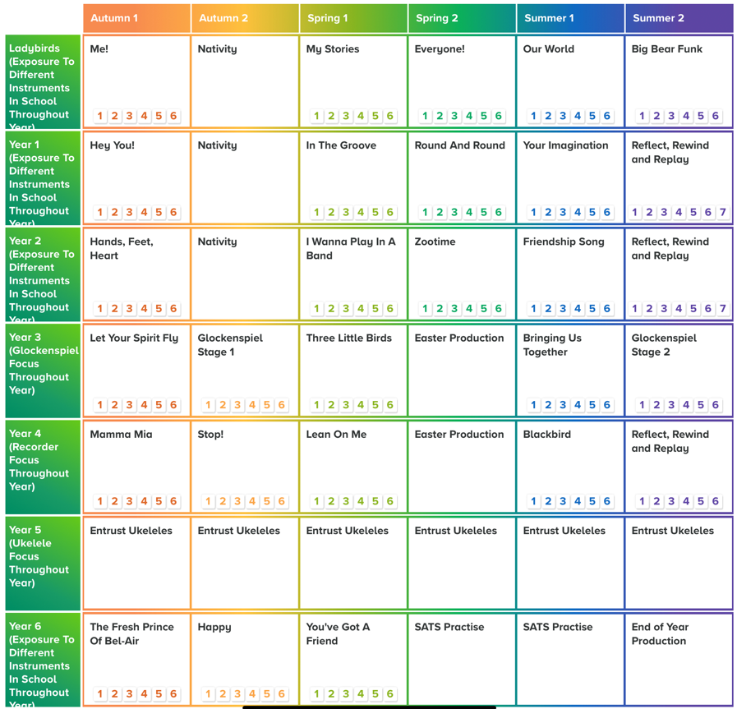

Part B: Extra-curricular music
This is about opportunities for pupils to sing and play music, outside of lesson time, and how pupils can make progress in music beyond the core curriculum.
- Small group lessons to learn to play the clarinet, flute or saxophone conducted by Entrust are offered. These will be 20 minute lessons weekly. These instruments are loaned out and children progress through levels. This is funded by parents/carers, with support offered to those if needed/available such as pupil premium.
- Rocksteady lessons (rock and pop band lessons) are offered for children to learn a range of instruments including keyboard, guitar, drums and vocals. Instrument provided by Rocksteady in school. This is funded by parents/carers, with support offered to those if needed/available such as pupil premium.
- KS2 (Year 3-6) Young Voices choir offered led by a staff member following Young Voices programme. This cumulates in a concert experience with many other primary schools.
- KS1 (Year 1-2) choir offered led by a staff member.

Part C: Musical experiences
This is about all the other musical events and opportunities that we organise.
- Weekly whole school music assembly
- Harvest festival service
- Whole school Christmas Carol Concert
- KS2 choir Christmas care home carols
- KS1 Nativity Peformance
- LKS2 Easter Production Peformance
- UKS2 End of Year Peformance
- Y3 Music Share Singing concert at Lichfield Cathedral

In the future
This is about what the school is planning for subsequent years.
- Snapshots are currently being implemented to ensure consistency amongst music lessons throughout school and to show evidence of progression.
- Explore how more practical elements can be added into music lessons and musical experiences, including increasing musical related trips/extra-curricular opportunities, increasing in-school performance opportunities and increasing musical instruments available.
- Continuing staff development of music subject knowledge
- Continue pupil and staff voice to monitor music offer within school
- Explore cultural heritage of children within the school and ensure this links with music on offer
- Explore how technology can enhance the music curriculum and extra-curricular opportunities

